**Experiment 2**

|  |  |
| --- | --- |
| **Student Name**: SANSKAR AGRAWAL | **UID:** 20BCS5914 |
| **Branch**: CSE | **Section/Group:** 806/B |
| **Semester**: 5th | **Date of Performance**: 10/08/2022 |
| **Subject Name**: DAA Lab | **Subject Code:** 20CSP-312 |

**1. Aim/Overview of the practical:**

Code implements power function in O (log n) time complexity.

**2. Task to be done/ Which logistics used:**

Vs Code IDE, C++ Language, C++ Compiler, Concepts of Recursion etc**.**

**3. Algorithm/Flowchart:**

The algorithm is simple implementation of following recurrence relation used to

calculate 'a' to the power 'b' where 'a' and 'b' are integers.

int power(int x, unsigned int y)

{

int temp;

if( y == 0)

return 1;

temp = power(x, y/2);

if (y%2 == 0)

return temp*temp;

else

return x*temp*temp;

}

**4. Code:**

//calculate pow(x,n) with time complexity O(log(n))

#include<iostream>

#include<cmath>

using namespace std;

int power(int x, int n)

{

if(n==0)

return 0;

else if(n%2==0)

return pow(x,n/2) * pow(x,n/2);

else

return x * pow(x,n/2) * pow(x,n/2);

}

int main()

{

int num,pow;

cout<<"enter number: ";cin>>num;

cout<<"enter power :";cin>>pow;

cout<<endl<<"output: "<<power(num,pow);

cout<<"\n\n\t---- SANSKAR AGRAWAL 20BCS5914";

}

**5. Observations/Discussions/ Complexity Analysis:**

The algorithm is simple implementation of following recurrence relation used to

calculate 'a' to the power 'b' where 'a' and 'b' are integers. The time complexity of this algorithm is O(log(b)) while computing power(a, b). This is because at every level in recursion sub-tree, we are doing only one computation (and using that value sub-sequent and there are log(b) levels overall. The time complexity of the algorithm is O(log n), where n is the power of the number x

**6. Output:**

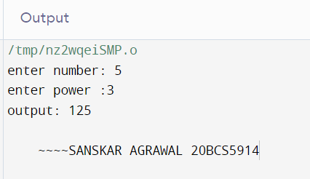

**Learning outcomes (What I have learnt):**

1. We learnt about time complexity.
2. We learnt to calculate time complexity of programs and thereby create the most optimal program possible.
3. We learned to create a program for calculating power with time complexity O(log n)

**Evaluation Grid (To be created as per the SOP and Assessment guidelines by the faculty):**

|  |  |  |  |
| --- | --- | --- | --- |
| Sr. No. | Parameters | Marks Obtained | Maximum Marks |
| 1. |  |  |  |
| 2. |  |  |  |
| 3. |  |  |  |
|  |  |  |  |